This document contains additional information for test plans that is likely to change.

Current Install Locations
The current locations for installers and serial numbers for activating products used in test plans.

Product Current Location

TestStand 3.5 \\nirvana\NIInstallers\Current\ni\TestStand\3.5
LabVIEW 8.0 \\nirvana\NIInstallers\Current\ni\LabVIEW\8.0\Windows\English
LabVIEW 8.01 \\nirvana\NIInstallers\Prerelease\LabVIEW\8.0.1\Daily
Driver CD \\nirvana\NIInstallers\Prerelease\DriverCD\2006.02\1344841
ICP 2.3 \\nirvana\NIInstallers\Current\NI\Ivi\ICP-2.3.0

Note that you should install LabVIEW 8.0 before installing LabVIEW 8.01, activate the 8.0 license and 8.01 will not need activation.

Serial Numbers:
P12A00200 should support auto activation on LabVIEW, CVI, or TestStand.

Files Referenced In TestPlans
API Changes //TestStand/Users/Jimmy/TypeLibDiff/Debug/TypeLibDiff.exe
Debug Options //TestStand/Tests/3.5/API/MemoryChecking/
Deploy with Foreign OSes //TestStand/Tests/4.0/Deployment
Diffing TestStand and Deployment Installs //TestStand/Dev/2.1/Trunk/Dev/Utils/chkfiles/chkfiles.exe
Filtering of files //TestStand/Tests/3.0/Deployment/Filtering/
Running Commmands After Deployment Install Installing CVI OI and TS Engine //TestStand/Tests/3.1/Deployment/Engine CVIOI/
Running Commmands After Deployment Install Displaying Dialogs & Macros //TestStand/Tests/3.1/Deployment/Display Dialogs/
Running Commmands After Deployment Install Installing LV OI built with LabVIEW 8 and TS Engine //TestStand/Tests/3.5/Deployment/Engine LVOI8 Acrobat
Running Commmands After Deployment Install Installing LV OI, acrobat and TS Engine //TestStand/Tests/3.1/Deployment/Engine LVOI Acrobat/
Operator Interfaces, Process Models and LabVIEW Environments \\nirvana\Software\Apps\Win\Perforce\Windows\2004.2 and \\TestStand\Users\Carlos
LabVIEW Examples //TestStand/Tests/3.5/LVBuildValidation/Examples/IVI Instruments For Testing Examples/hp34401a_MS.msi and //TestStand/Tests/3.5/LVBuildValidation/Examples/TestExamples.seq

Licensing LabVIEW
LabVIEW has a tool for getting licenses, for LabVIEW 8.0 or later. Earlier versions of LabVIEW do not require a license to run. This tool can also get specific licenses for LabVIEW or the LabVIEW Developer Licenses. To start the tool run \\nirvana\LVPublic\Licensing\GetLicense.exe

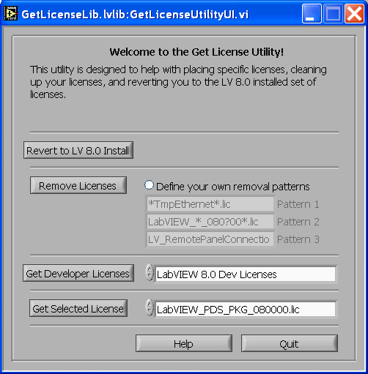

For testing 8.0, select LabVIEW_PDS_PKG_080000.lic and press the get selected License button (see screen shot above). If you plan on doing Scripting (or creating Xnodes) you press the Get Developer Licenses button.

